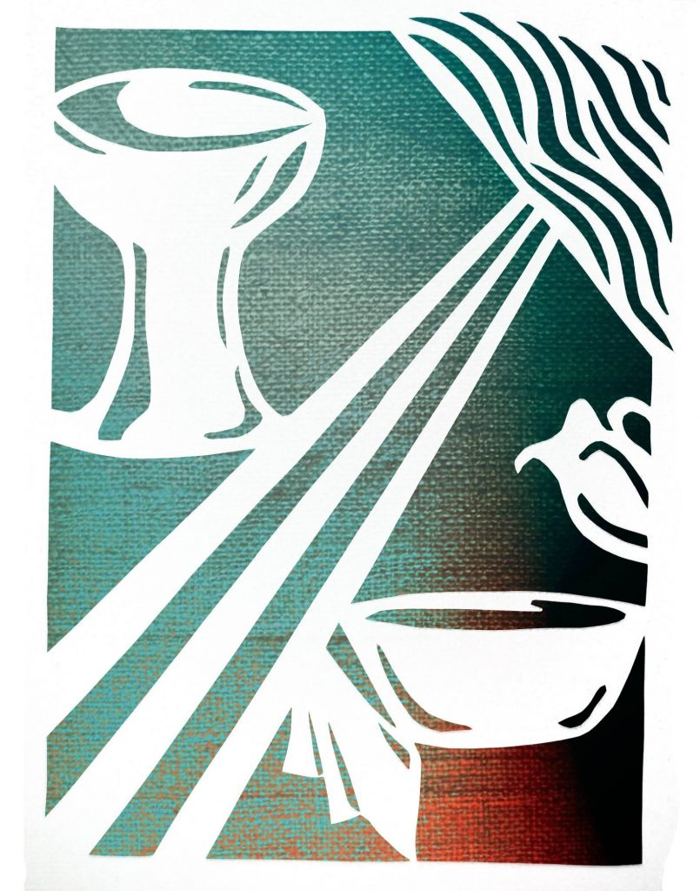
March 28th, 2024
Maundy Thursday

The Processional Hymn “When Jesus left his Father’s throne” Hymnal 1982 #480

Verse 1
When Jesus left his Father’s throne,
he chose an humble birth;
like us, unhonored and unknown,
he came to dwell on earth.
Like him may we be found below,
in wisdom’s path of peace;
like him in grace and knowledge grow
as years and strength increase.
Verse 2
Sweet were his words and kind his look,
when mothers round him pressed;
their infants in his arms he took,
and on his bosom blessed.
Safe from the world’s alluring harms,
beneath his watchful eye,
thus in the circle of his arms
may we for ever lie.
Verse 3
When Jesus into Zion rode,
the children sang around;
for joy they plucked the palms
and strowed
their garments on the ground.
Hosanna our glad voices raise,
hosanna to our King !
Should we forget our Savior’s praise,
the stones themselves would sing.

A Penitential Order: Rite I
Celebrant Bless the Lord who forgiveth all our sins.
People His mercy endureth for ever.
Celebrant
If we say that we have no sin, we deceive ourselves, and the truth is not in us; but if we confess our sins, God is faithful and just to forgive our sins, and cleanse us from all unrighteousness. 1 John 1:8, 9
Let us humbly confess our sins unto Almighty God.
Silence may be kept. The people kneel or stand.
Celebrant and People
Almighty and most merciful father,
we have erred and strayed from thy ways like lost sheep,
we have followed too much the devices and desires of our own hearts,
we have offended against thy holy laws,
we have left undone those things which we ought to have done,
and we have done those things which we ought not to have done.
But thou, O Lord, have mercy upon us,
spare thou those who confess their faults,
restore thou those who are penitent,
according to thy promises declared unto mankind
in Christ Jesus our Lord;
and grant, O most merciful Father, for his sake,
that we may hereafter live a godly, righteous, and sober life,
to the glory of thy holy Name. Amen.
Celebrant
The Almighty and merciful Lord grant you absolution and remission of all your sins, true repentance, amendment of life, and the grace and consolation of his Holy Spirit. Amen.
Celebrant Lord, have mercy upon us.
People Christ, have mercy upon us.
Celebrant Lord, have mercy upon us.
The Collect of the Day
Celebrant The Lord be with you.
People And with thy spirit.
Celebrant Let us pray.
Almighty Father, whose dear Son, on the night before he suffered, did institute the Sacrament of his Body and Blood: Mercifully grant that we may thankfully receive the same in remembrance of him who in these holy mysteries giveth us a pledge of life eternal, the same thy Son Jesus Christ our Lord; who now liveth and reigneth with thee and the Holy Spirit ever, one God, world without end. Amen.
The Lessons
The people sit.
The First Lesson Exodus 12:1-4, (5-10), 11-14
The Lord said to Moses and Aaron in the land of Egypt: This month shall mark for you the beginning of months; it shall be the first month of the year for you. Tell the whole congregation of Israel that on the tenth of this month they are to take a lamb for each family, a lamb for each household. If a household is too small for a whole lamb, it shall join its closest neighbor in obtaining one; the lamb shall be divided in proportion to the number of people who eat of it. [Your lamb shall be without blemish, a year-old male; you may take it from the sheep or from the goats. You shall keep it until the fourteenth day of this month; then the whole assembled congregation of Israel shall slaughter it at twilight. They shall take some of the blood and put it on the two doorposts and the lintel of the houses in which they eat it. They shall eat the lamb that same night; they shall eat it roasted over the fire with unleavened bread and bitter herbs. Do not eat any of it raw or boiled in water, but roasted over the fire, with its head, legs, and inner organs. You shall let none of it remain until the morning; anything that remains until the morning you shall burn.] This is how you shall eat it: your loins girded, your sandals on your feet, and your staff in your hand; and you shall eat it hurriedly. It is the passover of the Lord. For I will pass through the land of Egypt that night, and I will strike down every firstborn in the land of Egypt, both human beings and animals; on all the gods of Egypt I will execute judgments: I am the Lord. The blood shall be a sign for you on the houses where you live: when I see the blood, I will pass over you, and no plague shall destroy you when I strike the land of Egypt.
This day shall be a day of remembrance for you. You shall celebrate it as a festival to the Lord; throughout your generations you shall observe it as a perpetual ordinance.
Reader The Word of the Lord.
People Thanks be to God.
The Response Psalm 116:1, 10-17
1 I love the Lord, because he has heard the voice of my supplication, *
because he has inclined his ear to me whenever I called upon him.
10 How shall I repay the Lord *
for all the good things he has done for me?
11 I will lift up the cup of salvation *
and call upon the Name of the Lord.
12 I will fulfill my vows to the Lord *
in the presence of all his people.
13 Precious in the sight of the Lord *
is the death of his servants.
14 O Lord, I am your servant; *
I am your servant and the child of your handmaid;
you have freed me from my bonds.
15 I will offer you the sacrifice of thanksgiving *
and call upon the Name of the Lord.
16 I will fulfill my vows to the Lord *
in the presence of all his people,
17 In the courts of the Lord’s house, *
in the midst of you, O Jerusalem.
The Second Lesson 1 Corinthians 11:23-26
I received from the Lord what I also handed on to you, that the Lord Jesus on the night when he was betrayed took a loaf of bread, and when he had given thanks, he broke it and said, "This is my body that is for you. Do this in remembrance of me." In the same way he took the cup also, after supper, saying, "This cup is the new covenant in my blood. Do this, as often as you drink it, in remembrance of me." For as often as you eat this bread and drink the cup, you proclaim the Lord's death until he comes.
Reader The Word of the Lord.
People Thanks be to God.
The people stand for the Gospel Procession and Proclamation
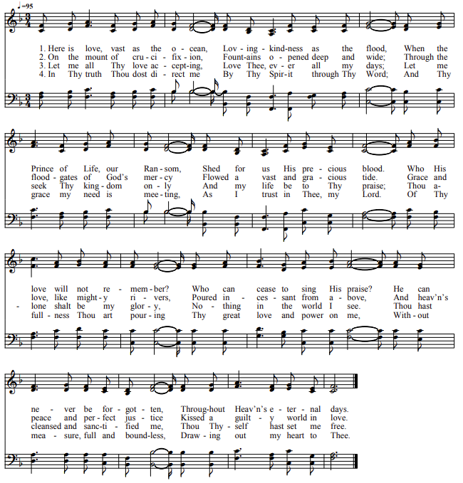
The Gospel Hymn “Here is Love”

The Holy Gospel John 13:1-17, 31b-35
Deacon The Holy Gospel of our Lord Jesus Christ according to John.
People Glory be to thee, O Lord.
Now before the festival of the Passover, Jesus knew that his hour had come to depart from this world and go to the Father. Having loved his own who were in the world, he loved them to the end. The devil had already put it into the heart of Judas son of Simon Iscariot to betray him. And during supper Jesus, knowing that the Father had given all things into his hands, and that he had come from God and was going to God, got up from the table, took off his outer robe, and tied a towel around himself. Then he poured water into a basin and began to wash the disciples' feet and to wipe them with the towel that was tied around him. He came to Simon Peter, who said to him, "Lord, are you going to wash my feet?" Jesus answered, "You do not know now what I am doing, but later you will understand." Peter said to him, "You will never wash my feet." Jesus answered, "Unless I wash you, you have no share with me." Simon Peter said to him, "Lord, not my feet only but also my hands and my head!" Jesus said to him, "One who has bathed does not need to wash, except for the feet, but is entirely clean. And you are clean, though not all of you." For he knew who was to betray him; for this reason he said, "Not all of you are clean."
After he had washed their feet, had put on his robe, and had returned to the table, he said to them, "Do you know what I have done to you? You call me Teacher and Lord--and you are right, for that is what I am. So if I, your Lord and Teacher, have washed your feet, you also ought to wash one another's feet. For I have set you an example, that you also should do as I have done to you. Very truly, I tell you, servants are not greater than their master, nor are messengers greater than the one who sent them. If you know these things, you are blessed if you do them.
Jesus said, "Now the Son of Man has been glorified, and God has been glorified in him. If God has been glorified in him, God will also glorify him in himself and will glorify him at once. Little children, I am with you only a little longer. You will look for me; and as I said to the Jews so now I say to you, `Where I am going, you cannot come.' I give you a new commandment, that you love one another. Just as I have loved you, you also should love one another. By this everyone will know that you are my disciples, if you have love for one another."
Deacon The Gospel of the Lord.
People Praise be to thee, O Christ.
The people sit.
The Sermon Deacon Justine Guernsey
The Ceremony of the Washing of Feet
The people stand and the Celebrant says
Fellow servants of our Lord Jesus Christ: On the night before his death, Jesus set an
example for his disciples by washing their feet, an act of humble service. He taught that strength and growth in the life of the Kingdom of God come not by power, authority, or even miracle, but by such lowly service. We all need to remember his example, but none stand more in need of this reminder than those whom the Lord has called to the ordained ministry.
Therefore, I invite you who share in the royal priesthood of Christ, to come forward, that I may recall whose servant I am by following the example of my Master. But come remembering his admonition that what will be done for you is also to be done by you to others, for “a servant is not greater than his master, nor is one who is sent greater than the one who sent him. If you know these things, blessed are you if you do them.”
To those wishing to take part in the foot-washing ceremony, please remove shoes and socks before coming forward. Everyone is encouraged to participate.
The Prayers of the People
The people kneel or stand.
In the power of the Holy Spirit, let us pray to the Father through Christ, the Savior
of the world.
Father, on this, the night He was betrayed, your Son Jesus Christ washed His disciples’ feet. We commit ourselves to follow His example of love and service.
Lord, hear us
and humble us.
On this night, He prayed for His disciples to be one. We pray for the unity of your Church.
Lord, hear us
and unite us.
On this night, He prayed for those who were to believe through His disciples’ message. We pray for the mission of your Church.
Lord, hear us
and renew our zeal.
On this night, He commanded His disciples to love, but suffered rejection Himself. We pray for the rejected and unloved.
Lord, hear us
and fill us with your love.
On this night, He reminded His disciples that if the world hated them it hated Him first. We pray for those who are persecuted for their faith.
Lord, hear us
and give us your peace.
On this night, He accepted the cup of death and looked forward to the new wine of the kingdom. We remember those who have died in the peace of Christ.
Lord, hear us
and welcome all your children into paradise.
Celebrant
Father, on this night, we commend ourselves and all for whom we pray, through Jesus Christ, our Lord. Amen.
The Peace
All stand. The Celebrant says to the people Jesus said: ‘Peace I leave with you; my peace I give to you. Do not let your hearts be troubled, neither let them be afraid.”
My brothers and sisters in Christ, the peace of the Lord be always with you.
People And with thy spirit.
The Holy Communion
Celebrant
Walk in love, as Christ loved us and gave himself for us, an offering and sacrifice to God.
Offertory Hymn “Who is that man?” St. Stephen’s Choir Anthem
The Doxology
The people stand.
Praise God from whom all blessings flow; Praise him, all creatures here below; Praise him above, ye heavenly host; Praise Father, Son and Holy Ghost. Amen.
As a sign of our thanksgiving, the Celebrant and people pray responsively
Celebrant All things come of thee, O Lord.
People And of thine own have we given thee.
The Great Thanksgiving
Eucharistic Prayer I
The people remain standing. The Celebrant faces them and says
The Lord be with you.
People And with thy spirit.
Celebrant Lift up your hearts.
People We lift them up unto the Lord.
Celebrant Let us give thanks unto our Lord God.
People It is meet and right so to do.
Then, facing the Holy Table, the Celebrant proceeds
It is very meet, right, and our bounded duty, that we should at all times, and in all places, give thanks unto thee, O Lord, holy Father, almighty, everlasting God. Through Jesus Christ our Lord; who for our sins was lifted high upon the cross, that he might draw the whole world to himself; who by his suffering and death became the author of eternal salvation for all who put their trust in him.
Therefore with Angels and Archangels, and with all the company of heaven, we laud and magnify thy glorious Name; evermore praising thee, and saying,
Celebrant and People
Holy, holy, holy, Lord God of Hosts:
Heaven and earth are full of your glory.
Glory be to thee, O Lord Most High.
Blessed is he that cometh in the name of the Lord.
Hosanna in the highest.
The people kneel or stand.
Then the Celebrant continues
All glory be to thee, Almighty God, our heavenly Father, for that thou, of thy tender mercy, didst give thine only Son Jesus Christ to suffer death upon the cross for our redemption; who made there, by his one oblation of himself once offered, a full, perfect, and sufficient sacrifice, oblation, and satisfaction, for the sins of the whole world; and did institute, and in his holy Gospel command us to continue, a perpetual memory of that his precious death and sacrifice, until his coming again.
For in the night in which he was betrayed, he took bread; and when he had given thanks, he brake it, and gave it to his disciples, saying, "Take, eat, this is my Body, which is given for you. Do this in remembrance of me."
Likewise, after supper, he took the cup; and when he had given thanks, he gave it to them, saying, "Drink ye all of this; for this is my Blood of the New Testament, which is shed for you, and for many, for the remission of sins. Do this, as oft as ye shall drink it, in remembrance of me."
Wherefore, O Lord and heavenly Father, according to the institution of thy dearly beloved Son our Savior Jesus Christ, we, thy humble servants, do celebrate and make here before thy divine Majesty, with these thy holy gifts, which we now offer unto thee, the memorial thy Son hath commanded us to make; having in remembrance his blessed passion and precious death, his mighty resurrection and glorious ascension; rendering unto thee most hearty thanks for the innumerable benefits procured unto us by the same.
And we most humbly beseech thee, O merciful Father, to hear us; and, of thy almighty goodness, vouchsafe to bless and sanctify, with thy Word and Holy Spirit, these thy gifts
and creatures of bread and wine; that we, receiving them according to thy Son our Savior Jesus Christ's holy institution, in remembrance of his death and passion, may be partakers
of his most blessed Body and Blood.
And we earnestly desire thy fatherly goodness mercifully to accept this our sacrifice of praise and thanksgiving; most humbly beseeching thee to grant that, by the merits and death of thy Son Jesus Christ, and through faith in his blood, we, and all thy whole Church, may obtain remission of our sins, and all other benefits of his passion.
And here we offer and present unto thee, O Lord, our selves, our souls and bodies, to be a reasonable, holy, and living sacrifice unto thee; humbly beseeching thee that we, and all
others who shall be partakers of this Holy Communion, may worthily receive the most precious Body and Blood of thy Son Jesus Christ, be filled with thy grace and heavenly benediction, and made one body with him, that he may dwell in us, and we in him.
And although we are unworthy, through our manifold sins, to offer unto thee any sacrifice, yet we beseech thee to accept this our bounden duty and service, not weighing our merits, but pardoning our offenses, through Jesus Christ our Lord;
By whom, and with whom, in the unity of the Holy Ghost, all honor and glory be unto thee, O Father Almighty, world without end. AMEN.
And now, as our Savior Christ hath taught us, we are bold to say,
People and Celebrant
Our Father, who art in heaven,
hallowed be thy Name,
thy kingdom come,
thy will be done,
on earth as it is in heaven.
Give us this day our daily bread.
And forgive us our trespasses,
as we forgive those who trespass against us.
And lead us not into temptation,
but deliver us from evil.
For thine is the kingdom, and the power, and the glory,
for ever and ever. Amen.
The Breaking of the Bread
Celebrant Christ our Passover is sacrificed for us;
People Therefore let us keep the feast.
Fraction Anthem: Jesus, Lamb of God Agnus Dei 1982 Hymnal #S 164
Jesus, Lamb of God:
Have mercy on us.
Jesus, bearer of our sins:
Have mercy on us.
Jesus, redeemer of the world:
Give us your peace.
Prayer of Humble Access
We do not presume to come to this thy Table, O merciful Lord, trusting in our own righteousness, but in thy manifold and great mercies. We are not worthy so much as to gather up the crumbs under thy Table. But thou art the same Lord whose property is always to have mercy. Grant us therefore, gracious Lord, so to eat the flesh of thy dear Son Jesus Christ, and to drink his blood, that we may evermore dwell in him, and he in us. Amen.
Facing the people, the Celebrant says the following invitation
The Gifts of God for the People of God. Take them in remembrance that Christ died for you, and feed on him in your hearts by faith, with thanksgiving.
The Ministration of Communion
Prayer for Spiritual Communion
For those unable to worship with us today, we include this prayer
In union, O Lord, with the faithful at every altar of your Church, where the Holy Eucharist is now being celebrated, I desire to offer you praise and thanksgiving. I present to you my soul and my body with the earnest desire that I may continually be united to you. And since I cannot now receive you with my own faith community, I beseech you to come spiritually into my heart. Strengthen me with your grace, Lord Jesus, and let me never be separated from you. May I live in you, and you in me, in this life and in the life to come. Amen.
(Spiritual Communion Prayer adapted from the Armed Forces Prayer Book, 1951)

Special Music The Lamb

Celebrant Let us pray.
Celebrant and People
Almighty and everliving God, we most heartily thank thee for that thou dost feed us, in these holy mysteries, with the spiritual food of the most precious Body and Blood of thy Son our Savior Jesus Christ; and dost assure us thereby of thy favor and goodness towards us; and that we are very members incorporate in the mystical body of thy Son, the blessed company of all faithful people; and are also heirs, through hope, of thy everlasting kingdom. And we humbly beseech thee, O heavenly Father, so to assist us with thy grace, that we may continue in that holy fellowship, and do all such good works as thou hast prepared for us to walk in; through Jesus Christ our Lord, to whom with thee and the Holy Ghost, be all honor and glory, world without end. Amen.
The Stripping of the Altar
All sit or kneel for a time of quiet meditation during the stripping of the altar. At the appointed time, all join the Celebrant in saying
Psalm 22
1 My God, my God, why have you forsaken me? *
and are so far from my cry
and from the words of my distress?
2 O my God, I cry in the daytime, but you do not answer; *
by night as well, but I find no rest.
3 Yet you are the Holy One, *
enthroned upon the praises of Israel.
4 Our forefathers put their trust in you; *
they trusted, and you delivered them.
5 They cried out to you and were delivered; *
they trusted in you and were not put to shame.
6 But as for me, I am a worm and no man, *
scorned by all and despised by the people.
7 All who see me laugh me to scorn; *
they curl their lips and wag their heads, saying,
8 "He trusted in the Lord; let him deliver him; *
let him rescue him, if he delights in him."
9 Yet you are he who took me out of the womb, *
and kept me safe upon my mother's breast.
10 I have been entrusted to you ever since I was born; *
you were my God when I was still in my mother's womb.
11 Be not far from me, for trouble is near, *
and there is none to help.
12 Many young bulls encircle me; *
strong bulls of Bashan surround me.
13 They open wide their jaws at me, *
like a ravening and a roaring lion.
14 I am poured out like water;
all my bones are out of joint; *
my heart within my breast is melting wax.
15 My mouth is dried out like a pot-sherd;
my tongue sticks to the roof of my mouth; *
and you have laid me in the dust of the grave.
16 Packs of dogs close me in,
and gangs of evildoers circle around me; *
they pierce my hands and my feet;
I can count all my bones.
17 They stare and gloat over me; *
they divide my garments among them;
they cast lots for my clothing.
18 Be not far away, O Lord; *
you are my strength; hasten to help me.
19 Save me from the sword, *
my life from the power of the dog.
20 Save me from the lion's mouth, *
my wretched body from the horns of wild bulls.
21 I will declare your Name to my brethren; *
in the midst of the congregation I will praise you.
22 Praise the Lord, you that fear him; *
stand in awe of him, O offspring of Israel;
all you of Jacob's line, give glory.
23 For he does not despise nor abhor the poor in their poverty;
neither does he hide his face from them; *
but when they cry to him he hears them.
24 My praise is of him in the great assembly; *
I will perform my vows in the presence of those who worship him.
25 The poor shall eat and be satisfied,
and those who seek the Lord shall praise him: *
"May your heart live for ever!"
26 All the ends of the earth shall remember and turn to the Lord, *
and all the families of the nations shall bow before him.
27 For kingship belongs to the Lord; *
he rules over the nations.
28 To him alone all who sleep in the earth bow down in worship; *
all who go down to the dust fall before him.
29 My soul shall live for him;
my descendants shall serve him; *
they shall be known as the Lord's for ever.
30 They shall come and make known to a people yet unborn *
the saving deeds that he has done.

With the stripping of the altar complete, the service ends with a reading from Mark 14:32-50
They went to a place called Gethsemane; and he said to his disciples, “Sit here while I pray.” He took with him Peter and James and John, and began to be distressed and agitated. And he said to them, “I am deeply grieved, even to death; remain here, and keep awake.” And going a little farther, he threw himself on the ground and prayed that, if it were possible, the hour might pass from him. He said, “Abba, Father, for you all things are possible; remove this cup from me; yet, not what I want, but what you want.”
He came and found them sleeping; and he said to Peter, “Simon, are you asleep? Could you not keep awake one hour? Keep awake and pray that you may not come into the time of trial; the spirit indeed is willing, but the flesh is weak.” And again he went away and prayed, saying the same words. And once more he came and found them sleeping, for their eyes were very heavy; and they did not know what to say to him. He came a third time and said to them, “Are you still sleeping and taking your rest? Enough! The hour has come; the Son of Man is betrayed into the hands of sinners. Get up, let us be going. See, my betrayer is at hand.”
Immediately, while he was still speaking, Judas, one of the twelve, arrived; and with him there was a crowd with swords and clubs, from the chief priests, the scribes, and the elders. Now the betrayer had given them a sign, saying, “The one I will kiss is the man; arrest him and lead him away under guard.” So when he came, he went up to him at once and said, “Rabbi!” and kissed him. Then they laid hands on him and arrested him. But one of those who stood near drew his sword and struck the slave of the high priest, cutting off his ear. Then Jesus said to them, “Have you come out with swords and clubs to arrest me as though I were a bandit? Day after day I was with you in the temple teaching, and you did not arrest me. But let the scriptures be fulfilled.” All of them deserted him and fled.

Please exit in silence
The all-night watch starts immediately. If you have signed-up, please remember to arrive promptly and wait for your replacement before leaving.
We pray that this will be a spiritually enriching time for you all.

Prayers and Intercessions from the Book of Common Worship 2006, CoE

Music copyright notices:
The following music is used by permission under CCLI #20689921 and Streaming Lic #20689938
Here is Love, #5827118
Who is that Man, #801260

The following music is used for performance and streaming by permission under ONELICENSE #A-73684
When Jesus left his father’s throne, #1036850
The Lamb, #00482

Good Friday
March 29th at 12:00pm
St. Stephen's will be hosting the Ecumenical Good Friday Service celebrated by the Capital Area Council of Churches. It will be an hour of meditations on the seven last words of Christ on the cross, each presented by pastors of the Capital Region.
and 7:00pm
Good Friday Liturgy
Holy Eucharist Rite 1

Great Vigil of Easter
Saturday, March 30th at 7:00pm
Eucharist of Easter

Easter Sunday, March 31st
at 8:00am and 10:30am

